DIAGRAMA DE CLASES

- BDWorDomination

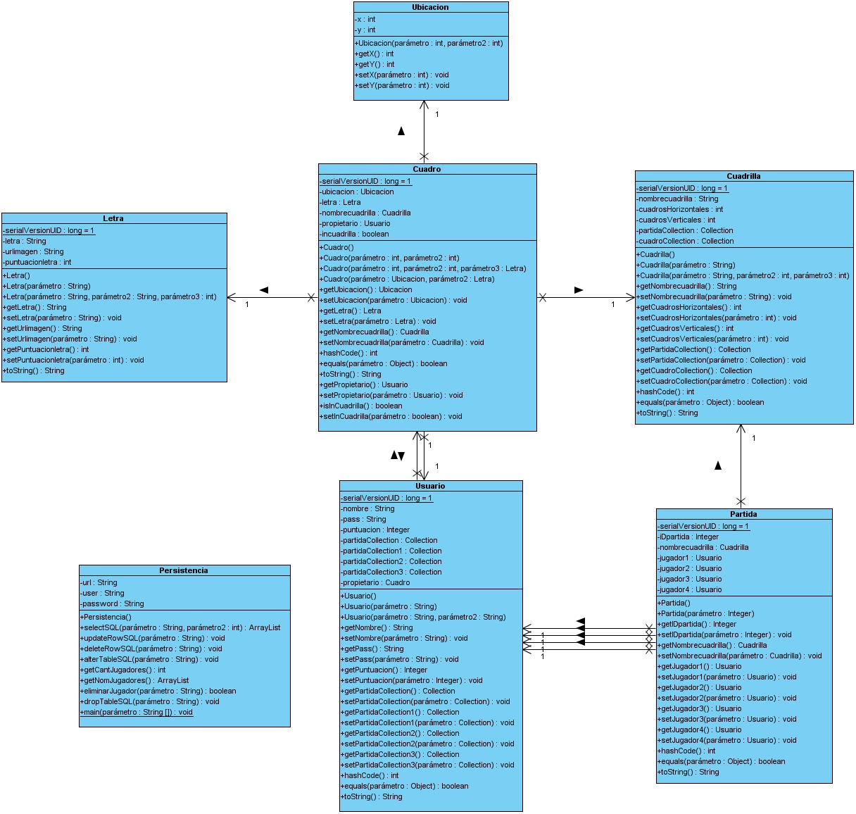

- WorDomination GUI

